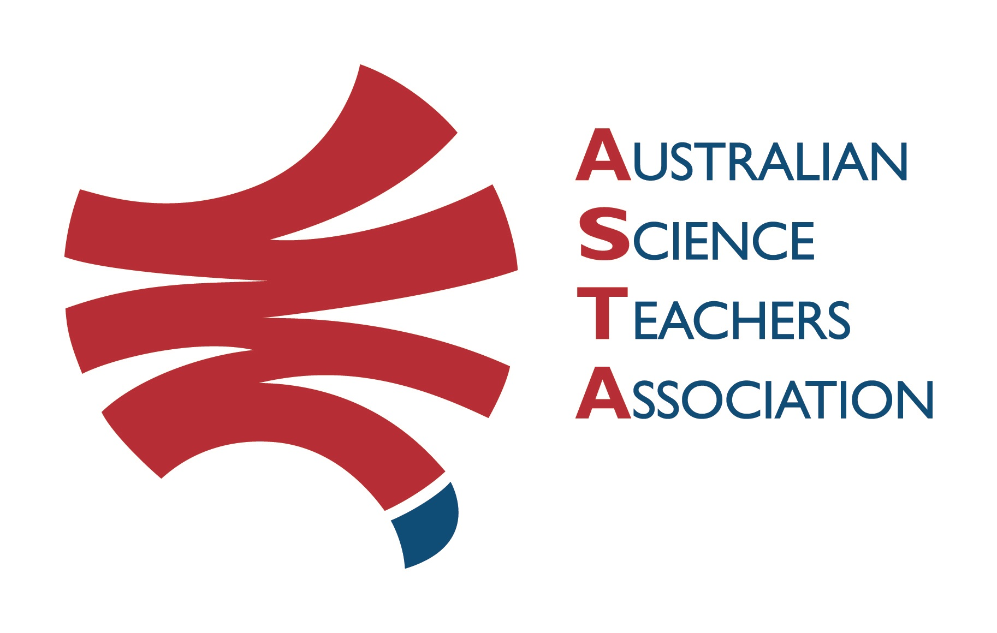
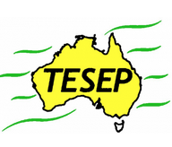

Professional Development Workshop Series in Earth and Environmental Science
TESEP PRESENTS: AFTER SCHOOL PROFESSIONAL DEVELOPMENT (PD)

Earth-Expo 2-PD - Introducing Our Dynamic Planet: Monday 13 May 2024
Rocks (the Rock Kit Teaching Pack & the Integrated Plate Tectonics story), yr 8-9
Riding the Climate Rollercoaster (climate through geologic time, plate tectonics/climate events in Earth’s history/fossil extinctions) yr 9-12 biology/genetics/geography crossover
School: Xavier Catholic College, 1 Wide Bay Dr, Eli Waters Qld
Meeting Room: attendees to go to the front desk to be directed to Meeting Room
Date: Monday 13 May 2024, PDs 3:20pm-5:30pm
School Facilitator: James Ferriere (afternoon tea will be provided)

The RocksExpo experience includes–
1. Incursions – classroom lessons with students and teachers.
2. PD workshops – After-school professional development workshops for teachers (2-PD @ $40 per attendee for visiting teachers, FREE to host-school teachers).
3. Certificate of attendance – A certificate of hours and workshop outcomes will be issued.
4. FREE rock kit – Host to receive a FREE rock kit and Plate Tectonics poster.
5. Introductory RocksExpo feature How to Use the Rock Kit and Teaching Pack (e.g. how to relate rock kit rocks to rock stories, 3D rendered samples, virtual thin sections and virtual outcrops).
Teacher Earth Science
Education Programme
6. Subsequent RocksExpo topics can be chosen from TESEP’s “The Challenging Earth” series 2
7. Rock collection checks – old school collections (on request, working with labtech).
Presenter: Philip Sansom is an experienced teacher and industry educator, with a passion for teaching earth science and local geology. He has many fossil and rock stories to share.
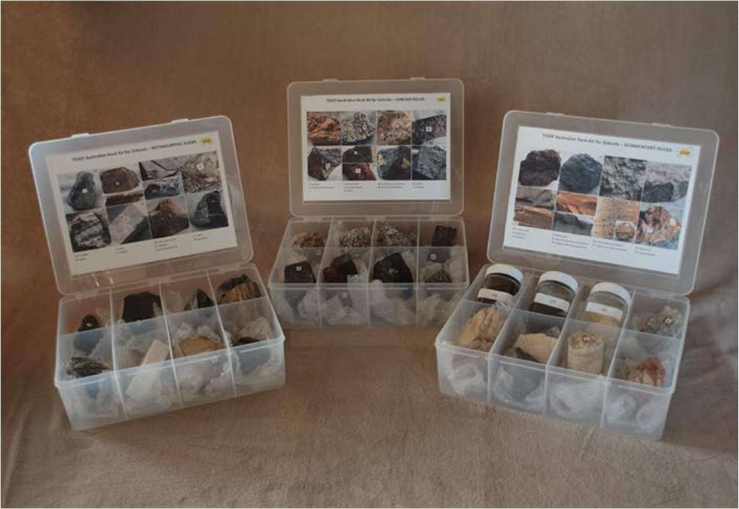

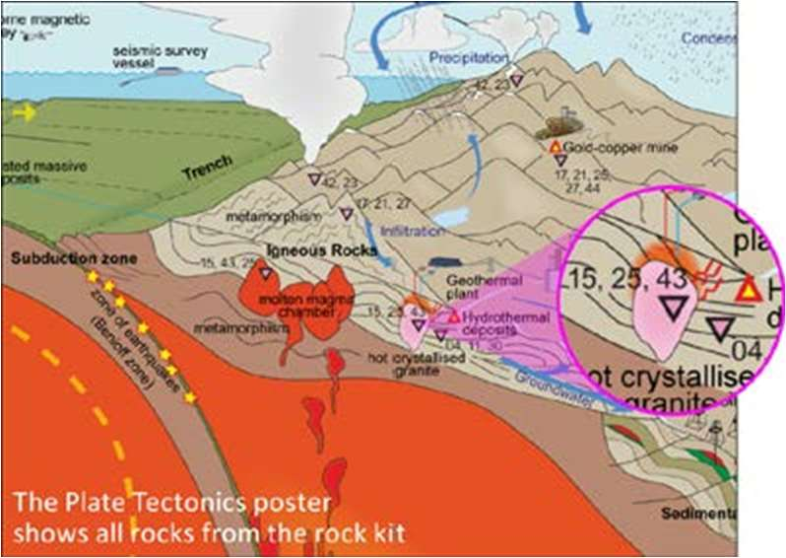

tesep.org.au

asta.edu.au

Booking form
please print clearly
Workshop: Xavier CC, Qld – 2-PD Rocks/rock kit/plate tectonics story, and Riding the Climate Rollercoaster | Date: Mon 13 May 2024
Venue: Xavier Catholic College, 1 Wide Bay Rd, Eli Waters | State: Qld

Registration fee: Free for teachers working at the host school and other sponsored schools. 2-PD event $40 per attendee from each other school.

Name:
School:
Teaching Area:
Phone (School):
Email:
Home postal address:
Special Dietary and other requirements:

Email or fax form to ASTA (office – Josh Fartch). Send the non-refundable* registration fee (includes GST) to Australian Science Teachers Association (ABN 87 902 882 824).
Payment can be made by direct bank transfer or cheque/money order. Please include your name and workshop details with payment (e.g. TESEP PD9 NSW July 20 J. Citizen).
*The fee is transferable to another PD workshop or for another teacher to substitute
Email: office@asta.edu.au | Address: TESEP - ASTA  PO Box 334 Deakin West ACT 2600
Account Details: Australian Science Teachers Association (ASTA) BSB: 082 902 Account No: 556 705 700

Please tick here if you require an invoice ☐ and provide address if different from the one above:

A certificate will be issued by ASTA which states the number of PD attendance hours. For registration inquiries contact registration@tesep.org.au
Please Note: Issuing of a certificate is conditional on workshop payment.

Professional Development Workshop Series in Earth and Environmental Science

