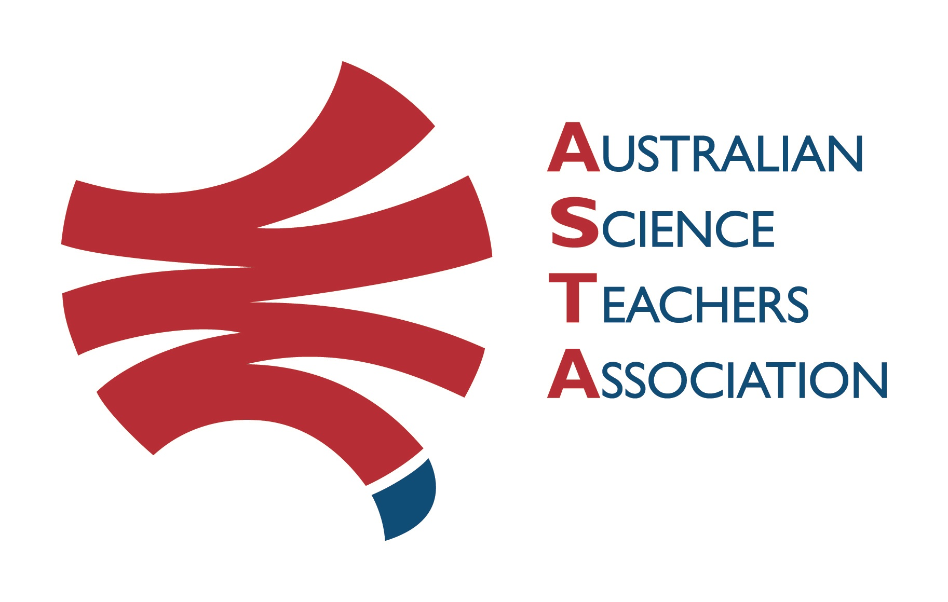
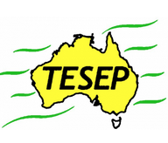

Professional Development Workshop Series in Earth and Environmental Science
TESEP PRESENTS: AFTER SCHOOL PROFESSIONAL DEVELOPMENT (PD)

Mon 29 July 2024, 8:30am-9:40am Short Local Fieldtrip, Loxton
10am-3pm 5-primary-oriented PDs 4 X Casual Relief Funds on application
Rocks (Rock Kit Teaching Pack, Plate Tectonics poster exercise)
Water Cycle & Wet Rocks (artesian water, porous rock exercise)
Our Place in Space (incl. Mars-Earth landform & other exercises)
Critical Minerals & Renewable Energy – electric car/recycling
Local Fossils & Explorer Box Exercise for SA (local geology of the region, sponge cake exercise, explorer box, videos)
Host School: Loxton Lutheran School, 6 Luther Rd, Loxton SA
Fieldtrip (details to follow registration)
PD Meeting Room: 10am go to front desk to be directed to STEM room Facilitator: Karl Klose
The RocksExpo experience includes– (with light lunch)
1. ASTA Certificate of attendance – A certificate of hours and workshop outcomes will be issued.
2. Introductory RocksExpo feature How to Use the Rock Kit and Teaching Pack (e.g. how to relate rock kit rocks to rock stories, 3D rendered samples, virtual thin sections and virtual outcrops).
Teacher Earth Science
Education Programme
3. Subsequent RocksExpo topics can be chosen from TESEP’s “The Challenging Earth” series 2
Presenters: Peter Nisbet is an experienced primary teacher/geologist. Glen Nash is an experienced energy and minerals geologist – both are educators in the stories of Earth history.

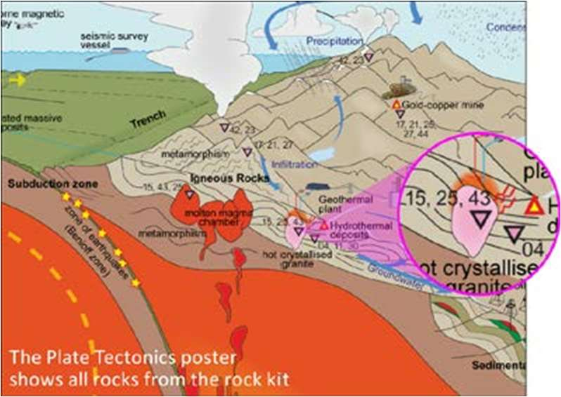
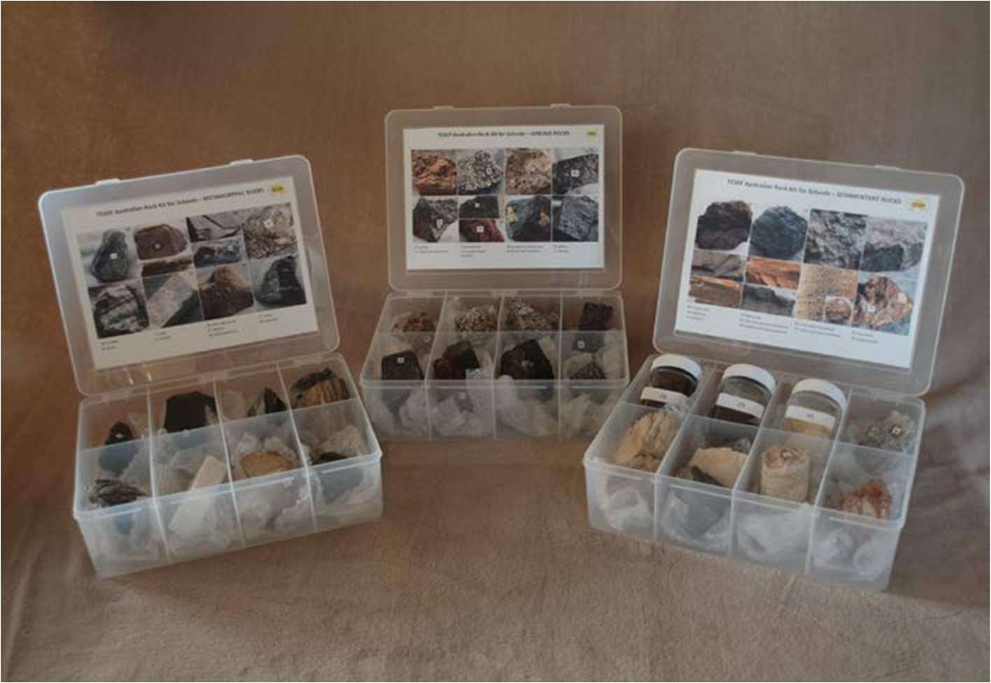

tesep.org.au

asta.edu.au
Booking form
please print clearly
Workshop: Loxton - short local fieldtrip & primary-oriented 5-PDs - Rocks, Wet Rocks, Space, Critical Minerals/Electric car, Fossils of SA, (local geology, with exercises) | Date: Mon 29 July 2024
Venue: Loxton Lutheran School, 6 Luther Rd, Loxton | State: SA

Name:
School:
Teaching Area:
Phone (School):
Email:
Home postal address:
Special Dietary and other requirements: 4 X $220 (excl GST) Casual Relief Funds on application – apply here (1 per school, 4 available only)

Professional Development Workshop Series in Earth and Environmental Science
Email or fax form to ASTA (office manager – Michelle Lollback). Send the non-refundable* registration fee (includes GST) to Australian Science Teachers Association (ABN 87 902 882 824).
Payment can be made by direct bank transfer or cheque/money order. Please include your name and workshop details with payment (e.g. TESEP PD9 NSW July 20 J. Citizen).
*The fee is transferable to another PD workshop or for another teacher to substitute
Email: officemanager@asta.edu.au | Address: TESEP - ASTA  PO Box 334 Deakin West ACT 2600
Account Details: Australian Science Teachers Association (ASTA) BSB: 082 902 Account No: 556 705 700

Please tick here if you require an invoice ☐ and provide address if different from the one above:

A certificate will be issued by ASTA which states the number of PD attendance hours. For registration inquiries contact registration@tesep.org.au
Please Note: Issuing of a certificate is conditional on workshop payment.

Registration fee: Free for teachers working at the host school and other sponsored schools. $65 per attendee for each other (non-sponsored) school.

